### Author

Name: Sejal Anand

Roll No: 21f1002620

Email ID: 21f1002620@student.onlinedegree.iitm.ac.in

### Description

This project requires the flashcard application created using flask to be converted into an app that uses VueJS for the frontend and Flask for the backend, communicating with API calls.

### Technologies used

Flask==1.1.2

Flask_Cors==3.0.10

Flask_Login==0.5.0

Flask_RESTful==0.3.9

Flask_Security==3.0.0

Flask_SQLAlchemy==2.5.1

Flask_WTF==1.0.0

SQLAlchemy==1.4.27

sympy==1.9

Werkzeug==2.0.2

WTForms==3.0.1

VueJS

### DB Schema Design

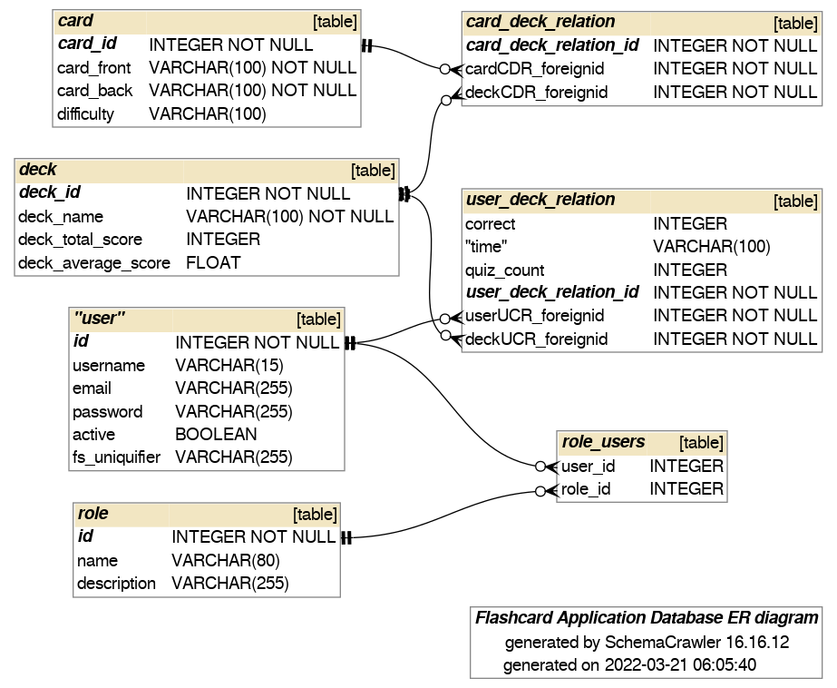

### Architecture and Features

Until now, flask security has been added to the existing application. API has been implemented. In the front end, Home Page, dashboard, login and Register page have been created as components while its connection to flask security is pending.

Further plan: Components for the dashboard, quiz and its result editing cards and decks will be implemented. APIs from the flask will fetch the data for all this. Further on, additional requirements such as batch jobs, etc. will be implemented.